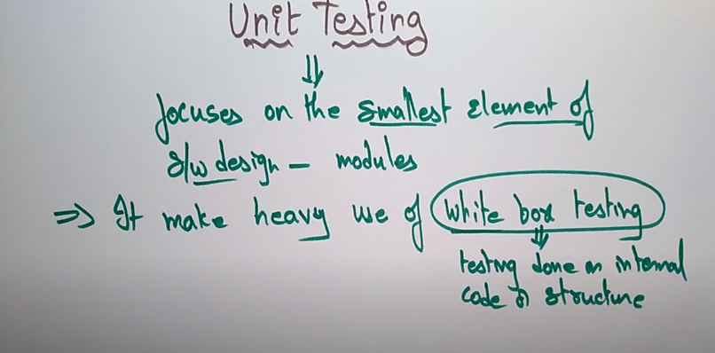  
https://www.youtube.com/watch?v=duW9Q6j0jaU&list=PLJ-3-UkU_it_-e8R0GwJ9OiLNrWyOObzM&index=10

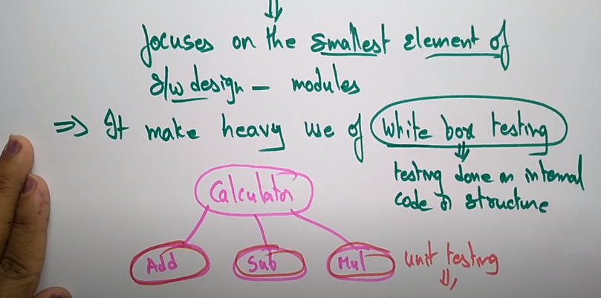

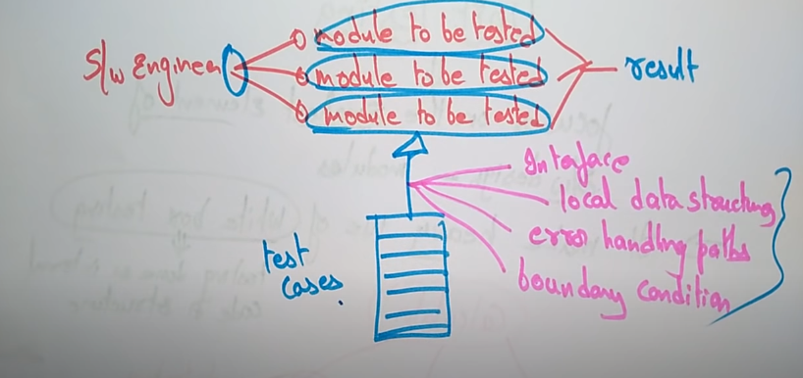

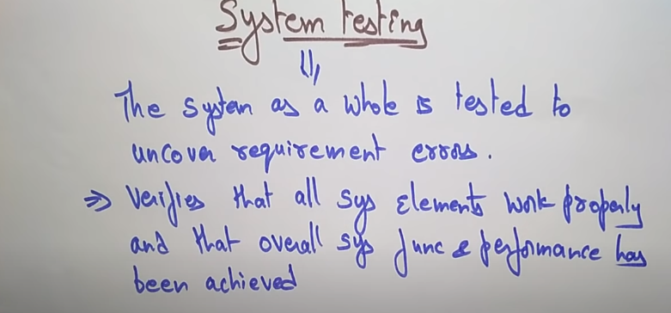

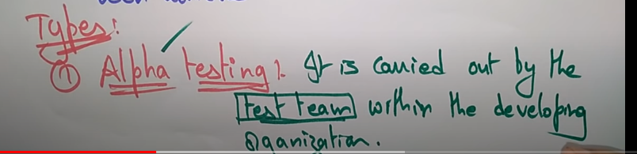

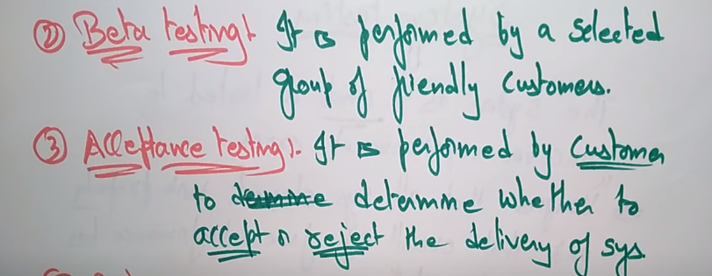

Black box testing means user requirement er upor miliye dekhano hoi sob kiso thik thak assay kina. Bivinnow dhoroner input output diye dekha hoi result thik assay kina boundary value use kora hoi. like calculator er vitorer kono function amra dekhtay pai na kito function gulo thik moto thik moto kaj korsay kina seta dekha tai holo black box testing

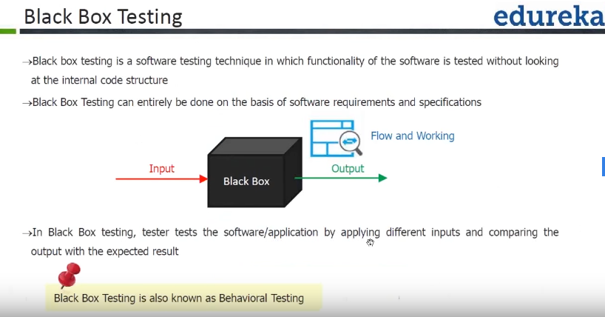

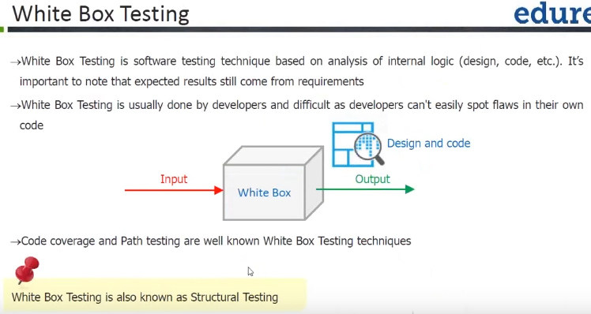

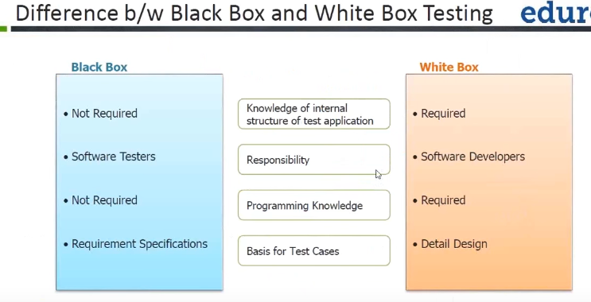

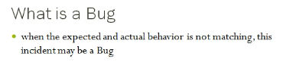

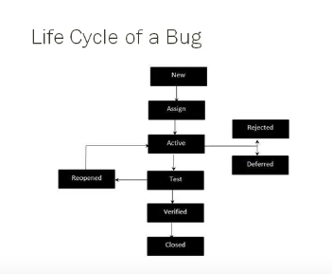

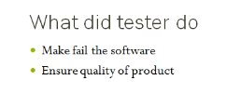

Compiler error---like windows er jonnow test korsay kinto jokhon mac or linux user oi project ta use korsay then problem create korsay ekhon ei error kay bolbo compiler error

Sql injection---like ekta software er database er vitore only admin othoba verified user entry kortay parbay kinto onnow ekjon hacker sekhanay enter koray database takay elomelo koray dilo are etar jonoow database ta kay prevent korar jonnow sql injection use kora hoi jeno verified user chara kew enter kortay na paray.

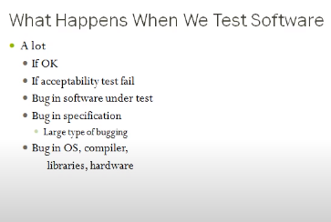

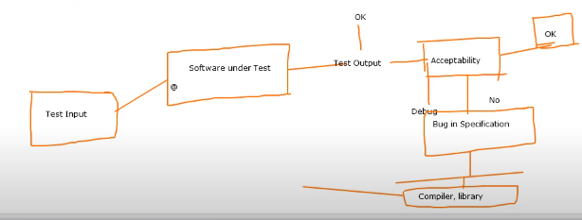

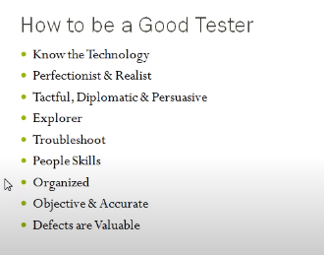

Know the technology----software er each part somporkay idea thaktay hobay.

Tactful----debug kora

Diplomatic----developer diye vul kajta koriye neya.

Perfectionist----nikhut vabay kajta kora orthat khut khut vab ar ki . ki korlay aro user friendly hoi software ta eita dekha

Explorer ---- user Jodi kono site diye bolay eirokom site create kortay hobay tokhon oi site ta valo koray dekhatai holo explorer.

Troubleshoot ---- onek dhoroner data niye test koratai holo troubleshoot.

People skill---- kono test fail holay developer er kas tekay adai koray newa tai holo people skill.

Kono software ei 100% bug free na

Big project e global variable use kora jabay na

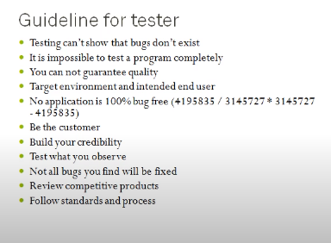

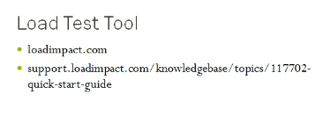

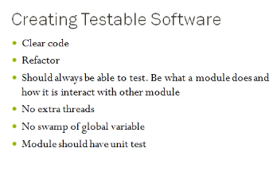

Load testing website-🡪loadimpact.com

Loadimpact.com------ kon site/kon page ta koto time nischay seta ber koray ei load time er maddomme. Beside onek besi user at a time besi enter korlay onek besi time niye thakay. Exact koto time nilo seta dekha jai ei website er maddomme. Then ekjon user e kono website e login korlay konto time nischay seta ber koray er maddomme. Maximum koto jon user dhuklay slow hobay setaw dekha jai er maddome, showing failing request, showing virtual user, showing active user.

Load impact e Jodi 3 to 8 sec er moddee assay then ok.

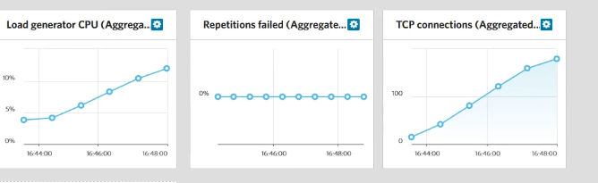

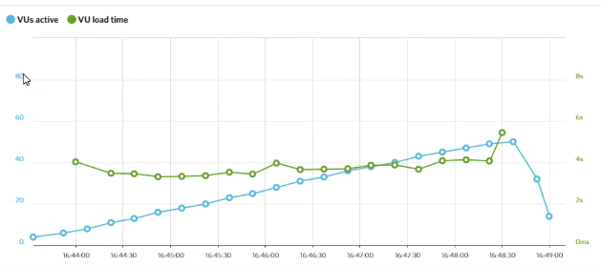

Dedicated server ---- own server

Free version er jonnow 50 user diye test kora jai ar paid holay million/cores porjonto dewa jai

Like facebook e 2 cores user at a time enter korlay site ta kamon hobay seta buja jai ei loadimpact tools er maddomme. , bandwidth maintain kora jai. Orthat at atime 10 jon user enter korlay ki poriman bandwidth lagbay seta ber kora jai.

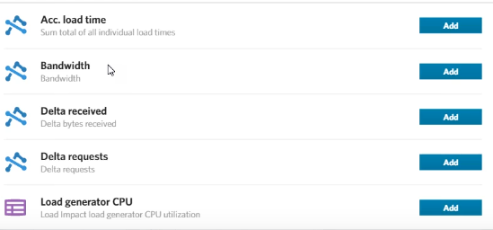

Google analytics ----- ekta website e koto jon user assay kon desh thekay join korsay eisob ei website er maddomme dekha jai. Kon city thekay astasay, kon city thekay besi astasay, google search er maddomee astasay naki facebook er maddomme astasay, naki twitter er maddomme astasay ei sob kiso dekha jai ei google analidtycs er maddomme.

8 sec er besi time laglay sei page ta frontend developer er kasay diye dewa hoi karon view page ta load nitay time besi lagay CSS, image, javaScript er jonnow. Eijonnow view page e kono javaScript code lekha jabay na er jonnow alada jaigai code likhtay hobay, view page e shudhu call koray dibo then kono inline CSS kora jabay na single line CSS holaw alada CSS likhtay hobay taholay code standard hobay beside load time komay jabay.

Besi poriman if else use korlay code slow hoye jai. Ejonnow soto soto function use kora valo.

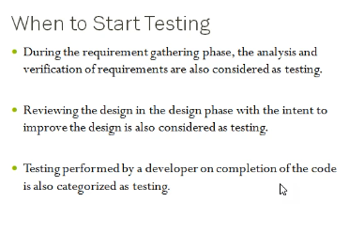

Unit test developer rai koray thakay.

Valo QA hotay holay code er access ditay hobay.

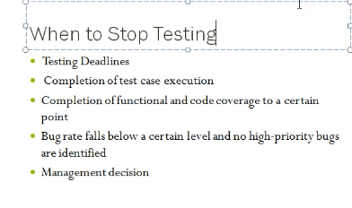

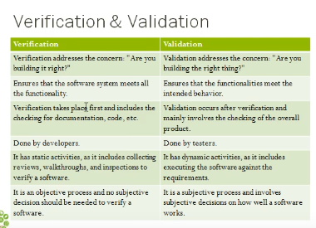

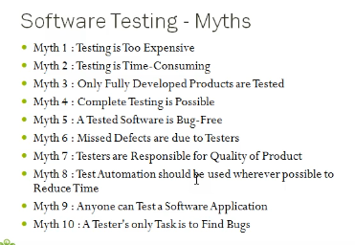

Mantis Bug tracker----bug tracker tool

Like ami ekta bug peyesi eita developer er kasay ki vabay jabay seta hobay bug tracker tool er maddomme. Then Jodi oi developer sign na koray then view ekhono koray nai seta dekhtay parbay SQA. Kobay deksay setaw dekhtay parbay ei tool er maddomme. Specific vabay je developer vul koray takay abar oita bugta assign koray ditay hoi.

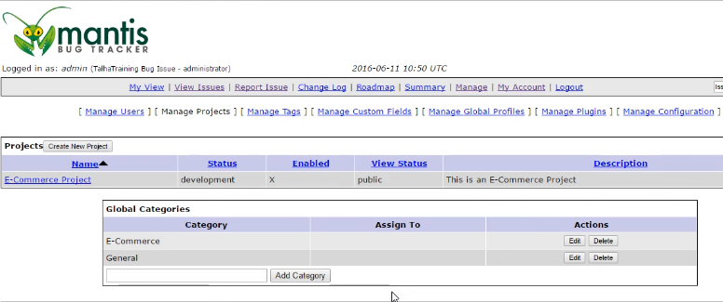

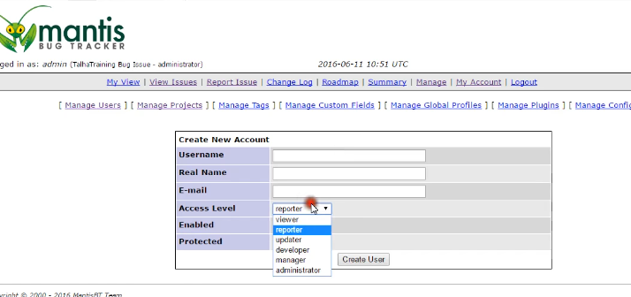

Private rakhlay specific vabay oi developer rai oi project e assign hobay.

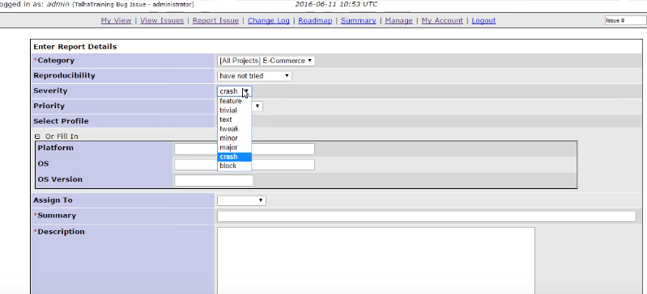

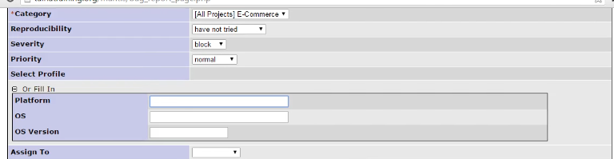

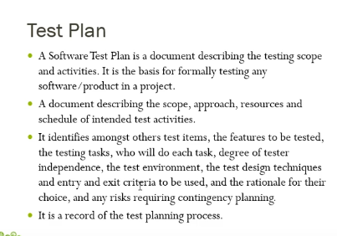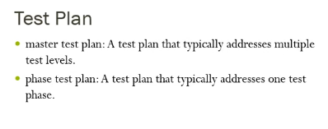

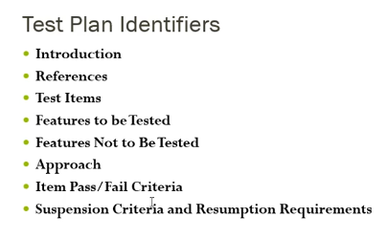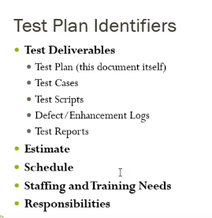

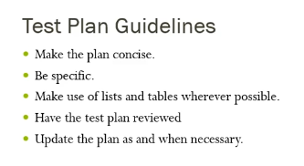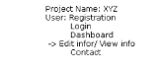

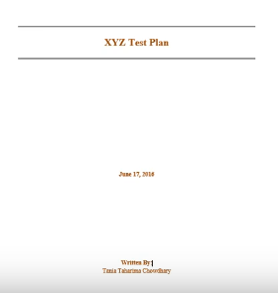 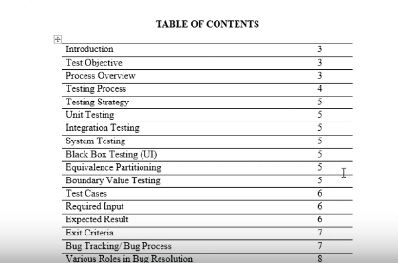

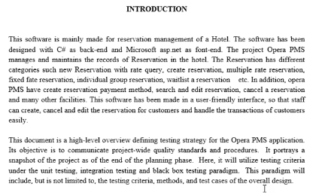

Backend e kon language use hobay ebong ki ki kaj koraty hobay seta likhtay hoi introduction e

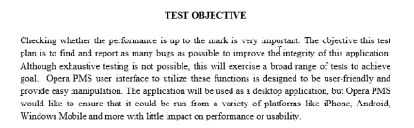

Objective e oi software e ki kaj hobay like user login, signup, edit, delete, update kortay hobay ei kaj gula objective e define kora hoi.

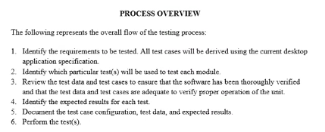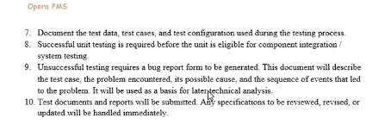

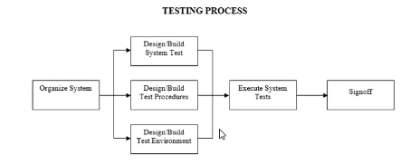

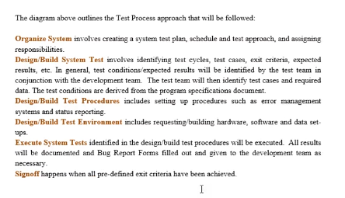

High level programming language-🡪 je gula compile hoi orthat C++, PHP, C# eigula high level programming language.

Low level programming language-> jegula interpreter er maddome run hoi like JavaScript, TypeScript eigular, assemlanguagebly compiler hoschay browser eigulakay low level programming language bolay.

Mid level programing language----C, objective C

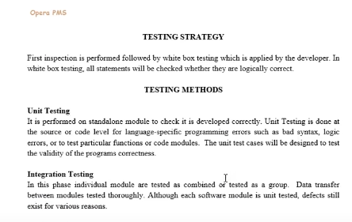

Load test, performance test, stress test eisob test kora jai javaScript janlay tools charai ar bug nijay solve kortay parlay onek valo QA howa jai.

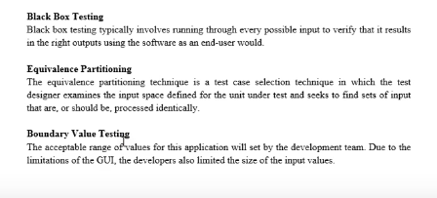

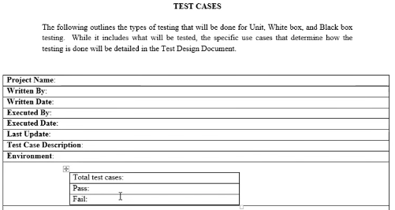

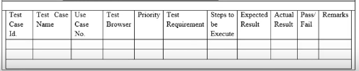

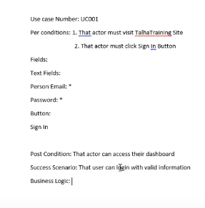

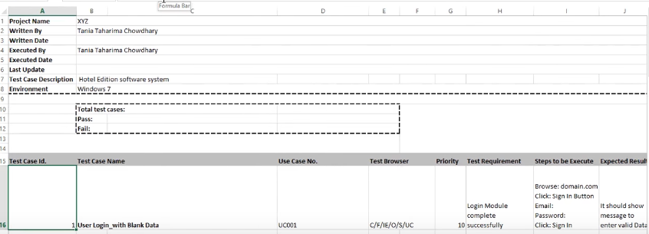

email er jonnow 6 ta test case

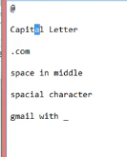 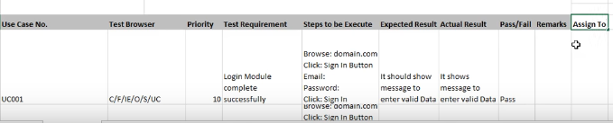

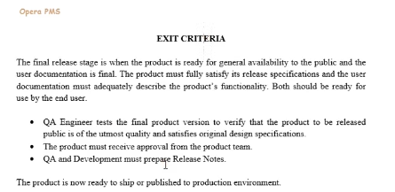

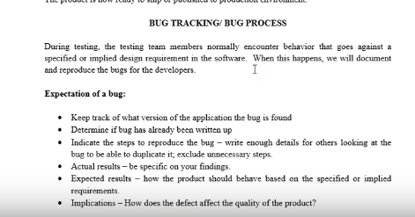

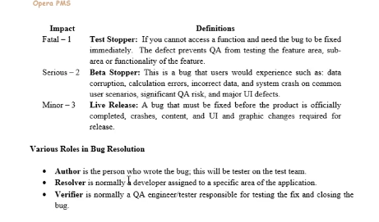

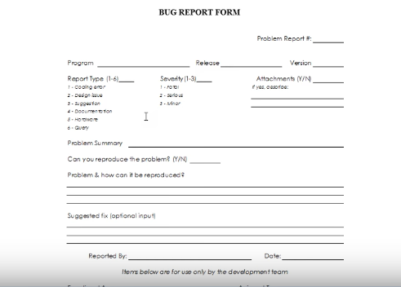

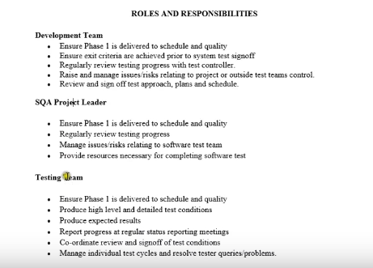

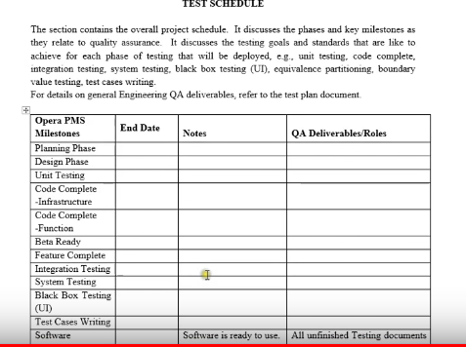

Beta test--- End customer/publicly diye test koranokay beta test bolay thakay.

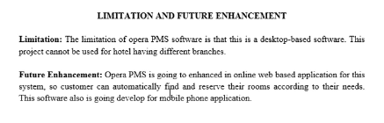

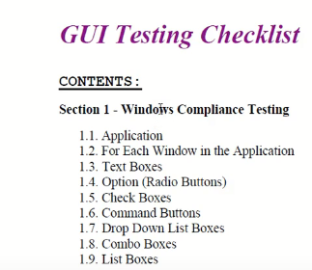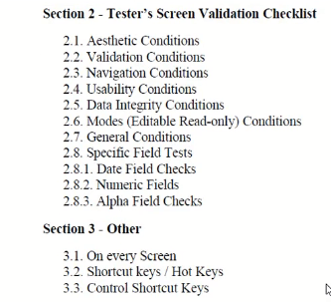

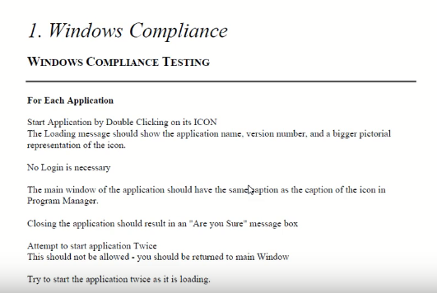

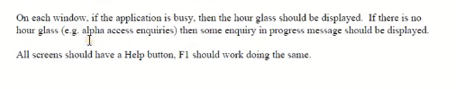

Ctrl+s --🡪means save korbay eirokom windows application e shortcut key thakbay eigula kay bola hoi hot key.

GUI----graphical user interface.

Windows application e ekta icon thakbay then click korlay onen hobay because install kora assay eikhanay kono password chaibay na aber looding hoitay 3-8 sec time niibay.eita ekta test case

Another test case hotay paray jokhon application ta close korbo then ekta warning dibay ami ki asolai chaise kin a bondho kortay eita ekta test case successfully test case ta pass korsay kina.

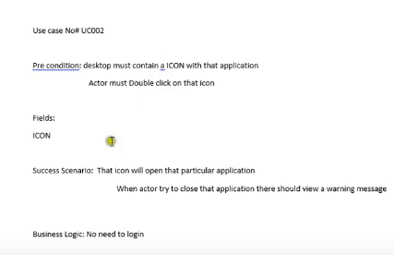



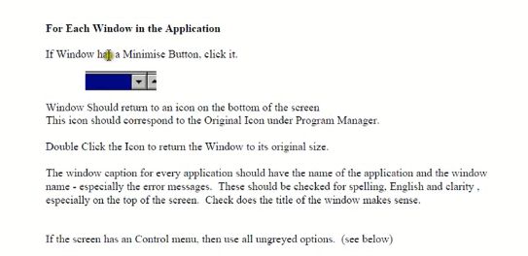

Desktop Software ta minimize hoschay kina , maximize hoschay kina eishob check kora hoi.

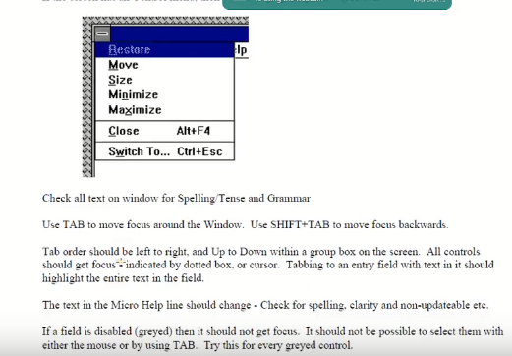

Windows application holay tab dilay forward hoi aber shift+tab dilay backward ei jai ei kaj gulaw windows application e thaktay hobay. Eigula hoschay GUI Testing

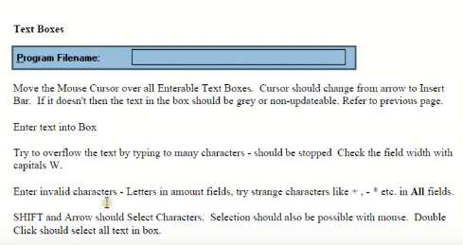

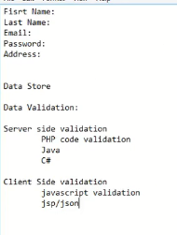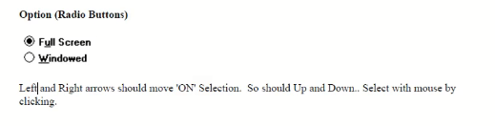

Checkbox use for multiple select korar jonnow

Radio button use for single item select korar jonnow.

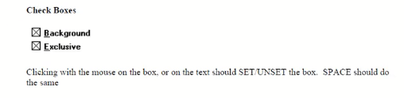

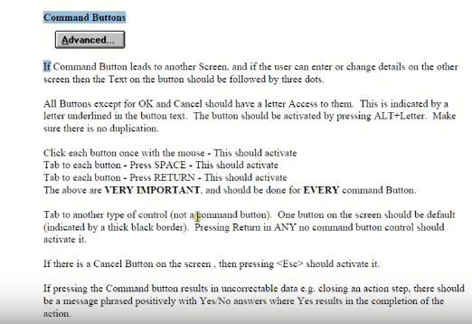

Command button means login button e click korlay successfully login holay test case success hobay ar na holay fail hobay.

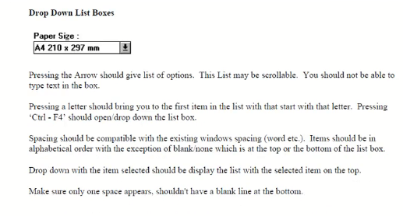

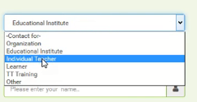

Textarea--- multiple row multiple column thakay

Testfield--- single row and single column thakbay.

Hacking er code lekha hoi javaScript diye maximum khetray

Javascript er code diye load test kora jai paid tool use na koraw kora jai ei javaScript diye.

GUI testing ta hoschay Black Box testing

Ekta part sesh holay GUI testing kora hoi.



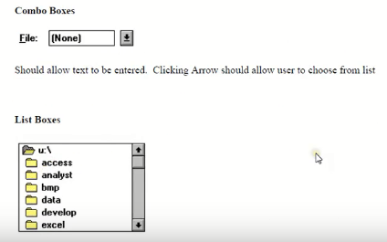

javaScript page e validation ditay hoi aber pbp page o validation ditay hoi.

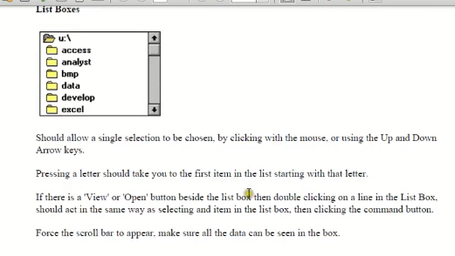

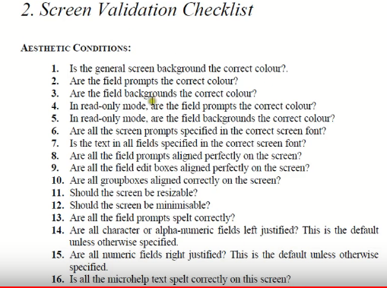

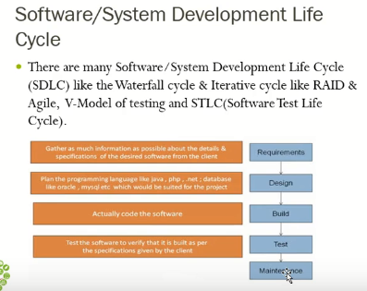

Banking software gulo java diye kora hoi.

Facebook PHP diye tairy.

Google python diye tairy

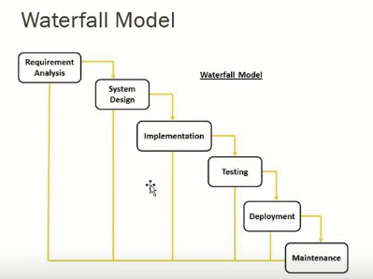

Extra payment koraw extra feature add kora jai na exact feature agay bolay ditay hoi. Firstly all requirement agay bolay ditay hoi

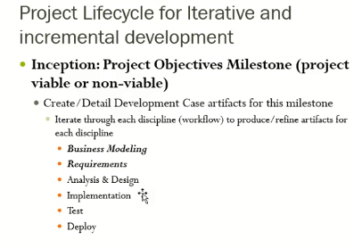

Agile model holo onek gulo iterative model er combination

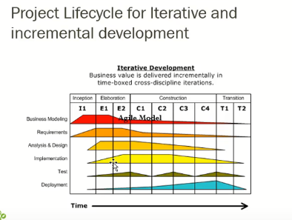

Sobcheye kom bag powa jai google ar Microsoft e tara module wise kaj kora thakay



Circle gula holo iterative model ar sob gulur combination e holo agile model. Protiti iterative model er alada alada test case, deploy ,build ei sob thakay.

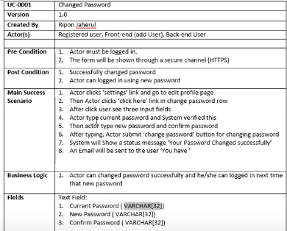

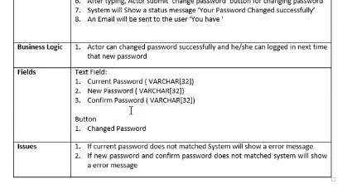

Use case create koray business analist ra ar use case dekhe test case create koray SQA ra

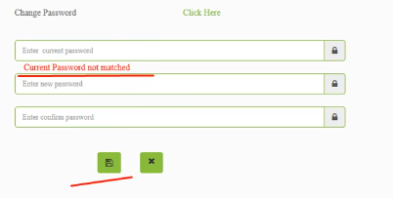

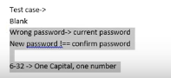

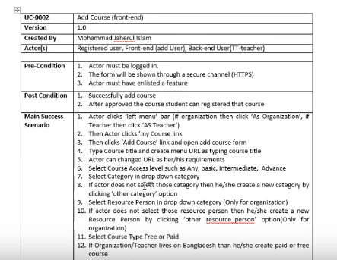

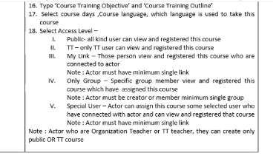

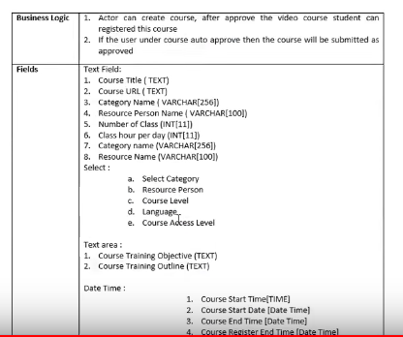

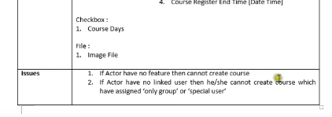

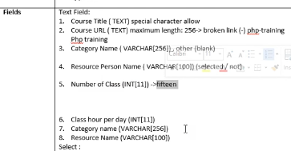

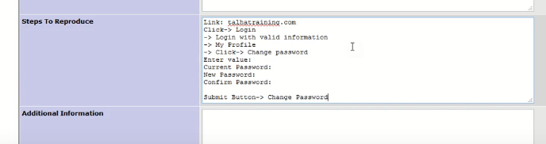

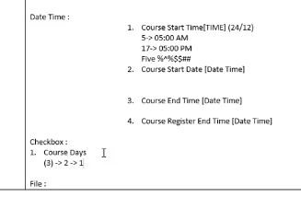

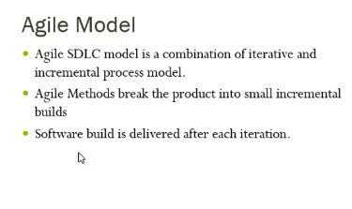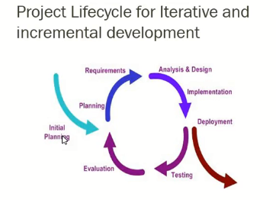

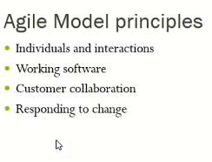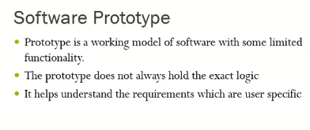

User document dewar por amra je kaj ta buztay peraysi tokhon free prototype software assay oikhan thekay prototype create koray client kay diye dewa hoi tokhon client seta dekhe buzay kajta tara tortay parbay tokhon tader kajta diye dai

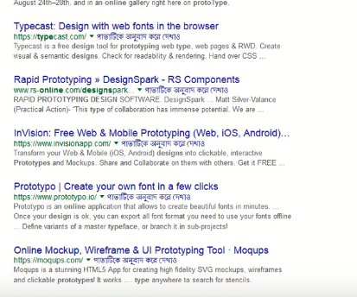 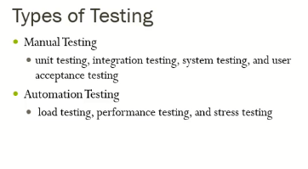

Integration test--- like bank account er balance check, withdraw money, deposit money eigula ekta arekter sathay dependent ar ai dependency test korakai bola hoi integration test.

User acceptance test----like ami ekta project baniye client kay dilam tar requirement onujayi kino majkhanay kiso jinis dewa hoi nai otoba change koray disay ei obastahai user product na niye back koray dilo orthat user product ta accept korlo na then ei test ta holo user acceptance test. Jeta asolay client test koray thakay. Echaraw user Jodi bolay ok then ok etai user acceptance test.

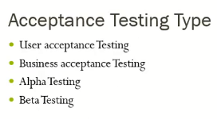

Alpha testing --- publicly dewa hoi na employee der modde dewa hoi test korar jonnow ar etakay bolay alpha testing

Beta testing---- user er kasay diye dewa hoi a rei test kay bola hoi beta testing

Responsive Mobile design testing

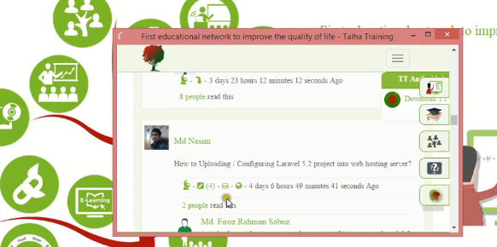

Broken Link--- like ami ekta page e click korlam kinto oi page ta aslo na google return korlo 404 page not found.tokhon oi linktakay bolay broken link. Ekta page er moddee onek somoy onek link thakay beside onek page thakay tar upor aber onek link assay taholay ekjon SQA er ekar pokkhay protiti link dhoray dhoray check kora possible hoi na tokhon tool use koray easily kora jai.

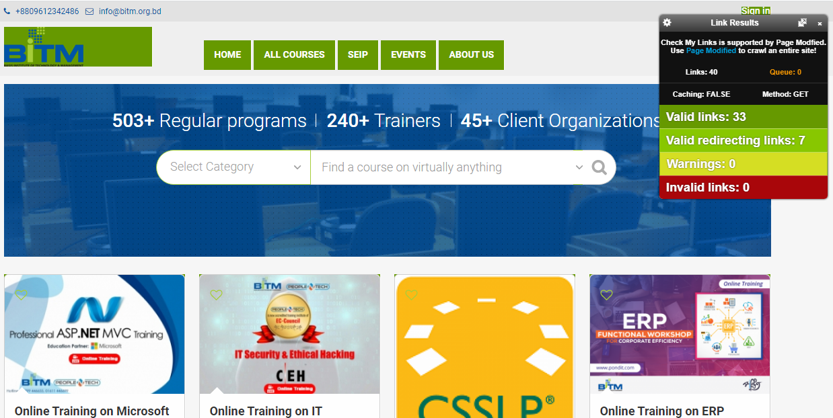

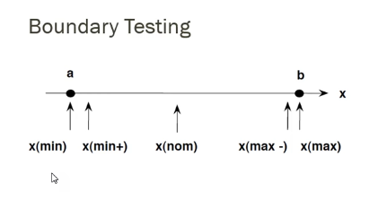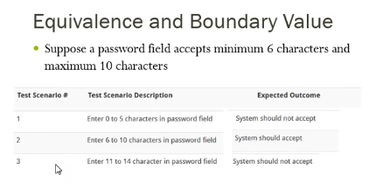

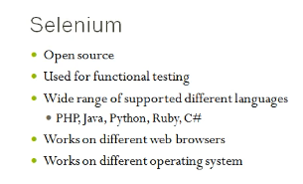

Java er jonnow eclips khub ei valo ekta id

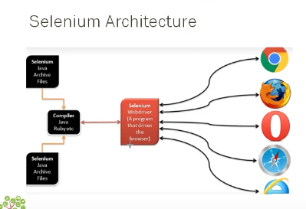

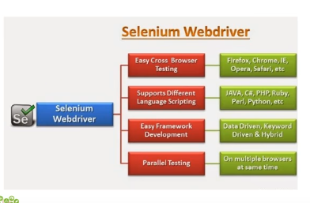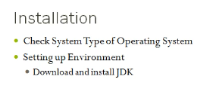

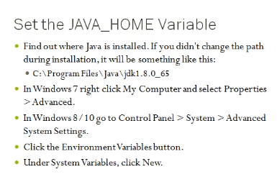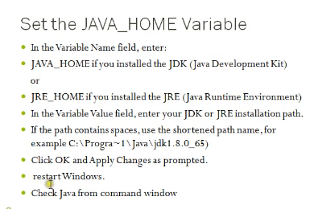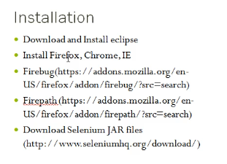

Selenium hoschay ekta open source framework

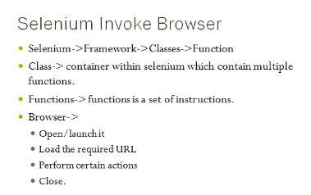

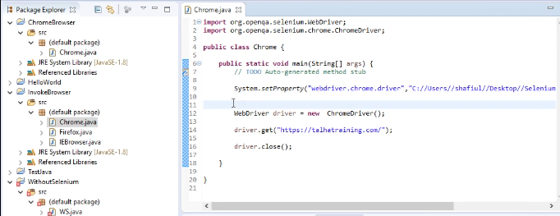

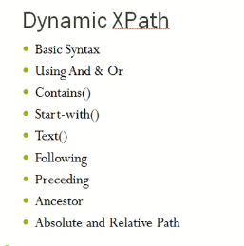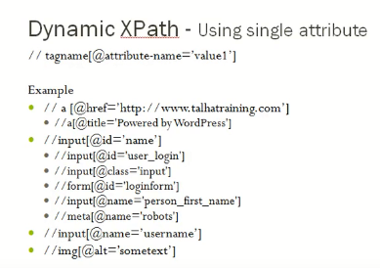

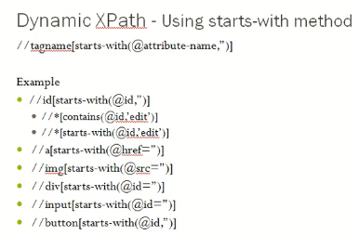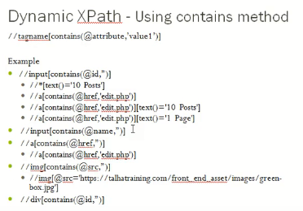

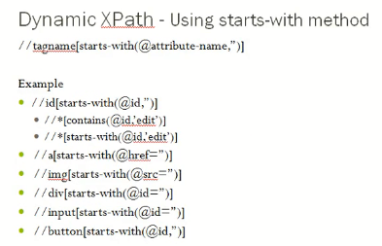

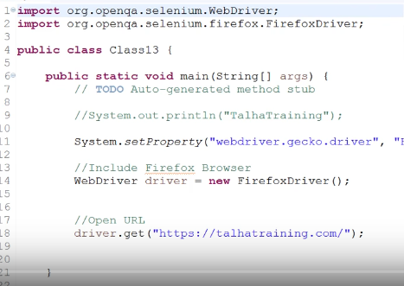

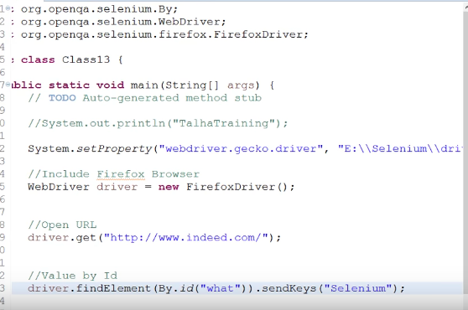

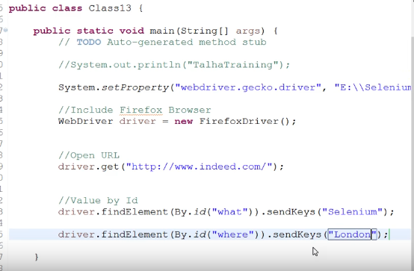

Selenium webdriver, selenium IDE,

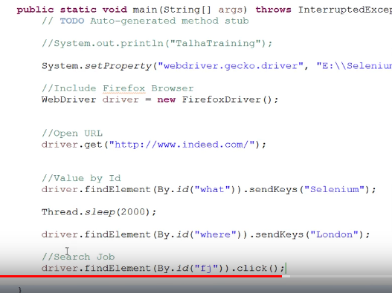

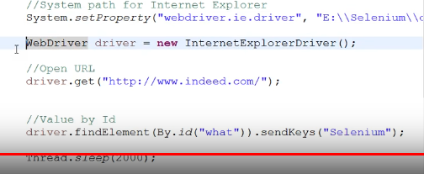

When internet explorer does not work properly then setting change which will be high

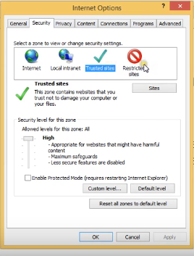 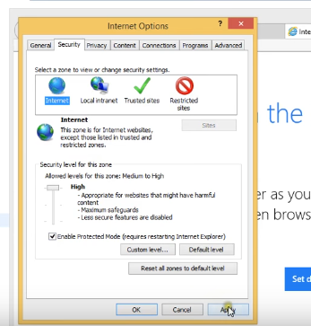

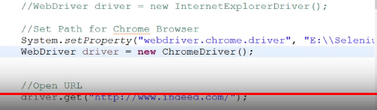

Human being dara Jodi kono kaj korano hoi then oita hoi manual testing and automated way tay jeta kora hoi oita hoi automation

Automated testing-----webDriver, IDE, loadtesting

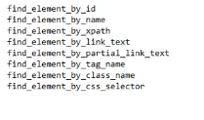

Check window maximize and minimize

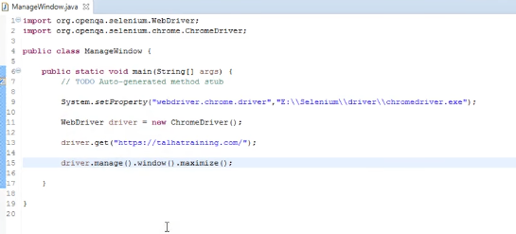

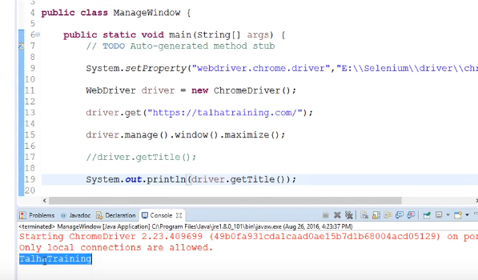

Check the tittle

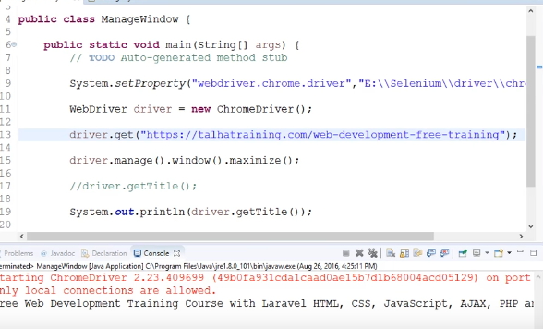

Output

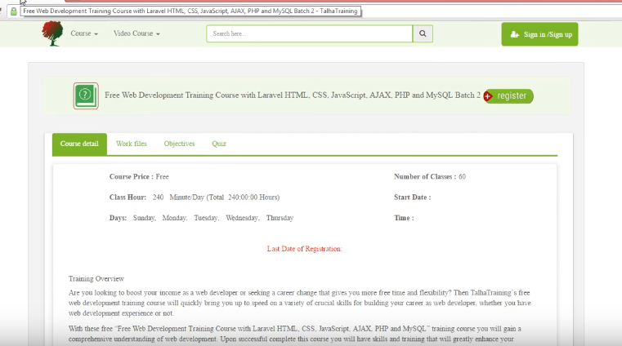

Check url

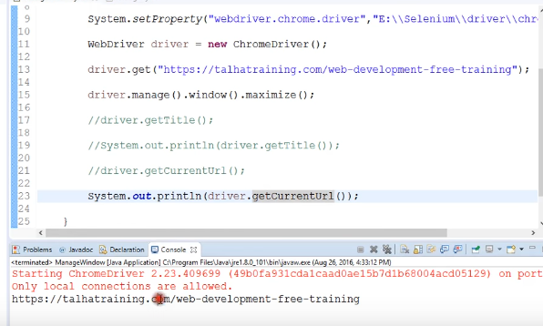

Check the page Source code

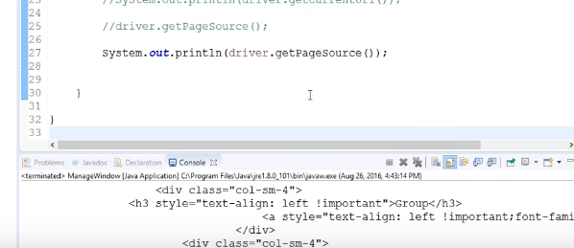

2 sec por server ta close hoye jabay

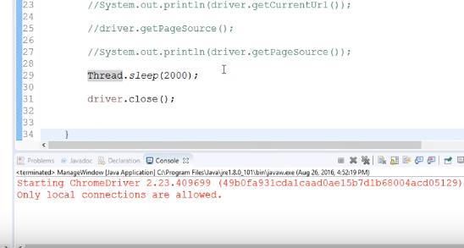

Id khujay ber kora jai xPath er sahajjee

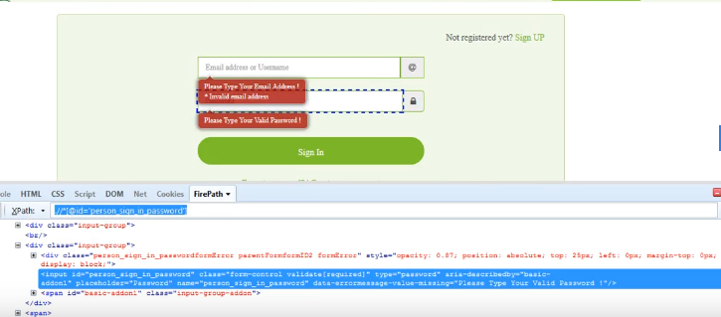

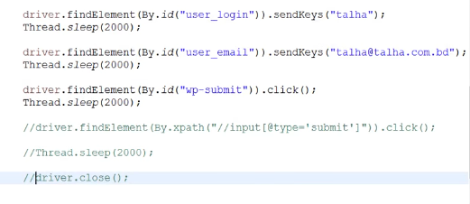

Keyboard diye joto value dai sobgulai sendKeys

Check by name

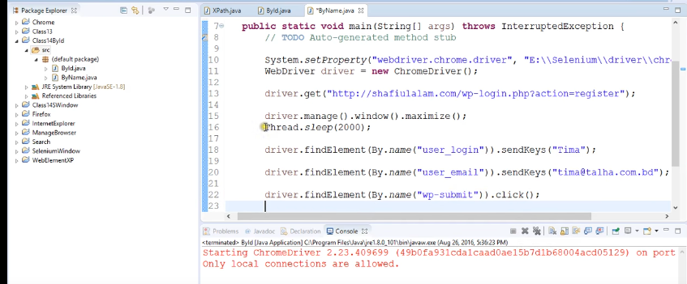

output

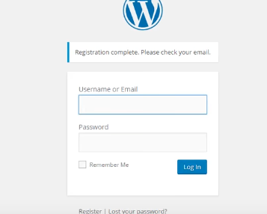

Ekta link thekay onnow link e jowa

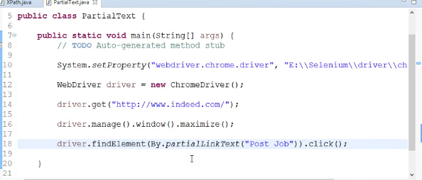

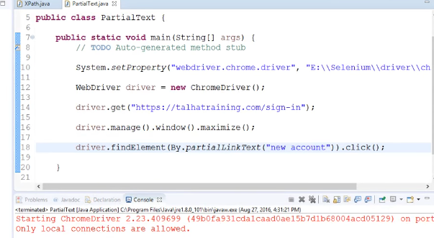

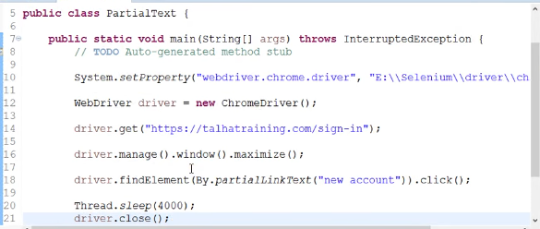

Check the linkText

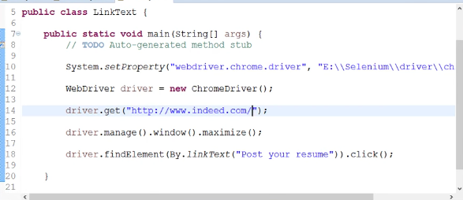

xPath dui prokar

1. Relative xPath-🡪xPath diye dai
2. Customize xPath

Relative xpath

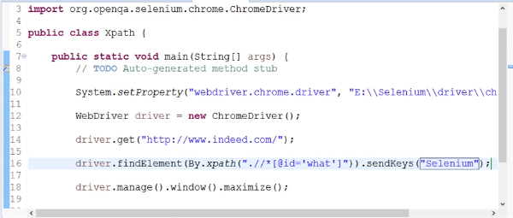

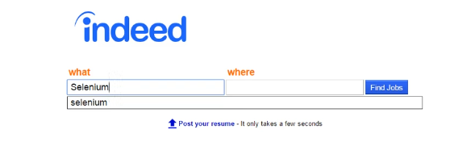

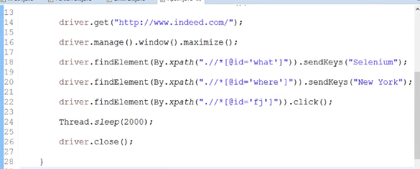

output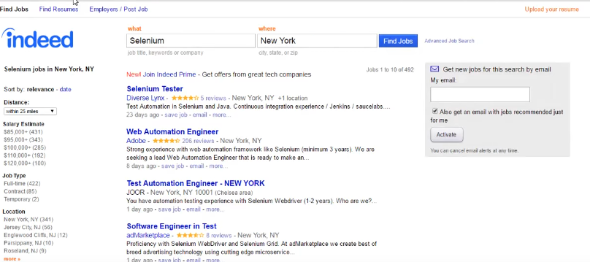

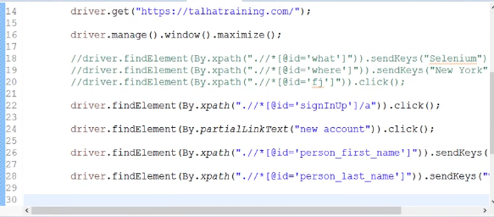

Check customixe xpath

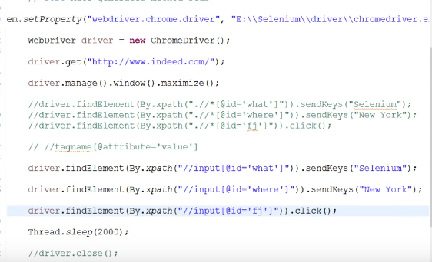

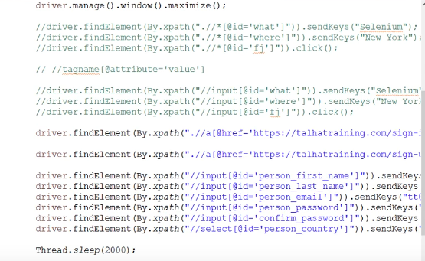

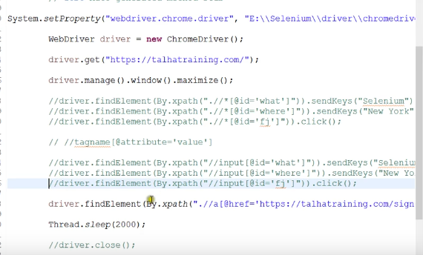

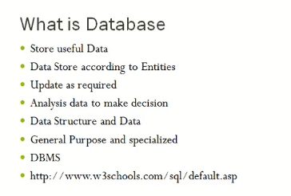

varchar memory fixed koray rakhay like varchar use korlam then memory size dilam 30 then ami input dilam “ashik” taholay o memory tay 30 character er space niye rakhbay etay koray memory er proper use hoi na but varchar use korlay number, special character, number sobkiso use kora jai.

Text use korlay ashik input dialy only 5 character er space nibay baki gula nibay na. kinto eikhanay special character use kora jai na.

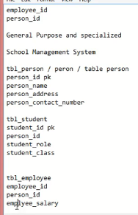 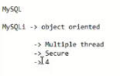

Parallel table--- jokhon duita table er primary key niye esay ekta table create kora hoi tokhon takay parallel table bolay.

